**Practical No: 5**

**Aim: Analyze the packets provided in lab and solve the questions using Wireshark:**

**-What web server software is used by www.snopes.com?**

**-About what cell phone problem is the client concerned?**

**-According to Zillow, what instrument will Ryan learn to play?**

**-How many web servers are running Apache?**

**-What hosts (IP addresses) think that jokes are more entertaining when they are**

**explained?**

**Steps:**

**1.Open the AskSnopes file.**

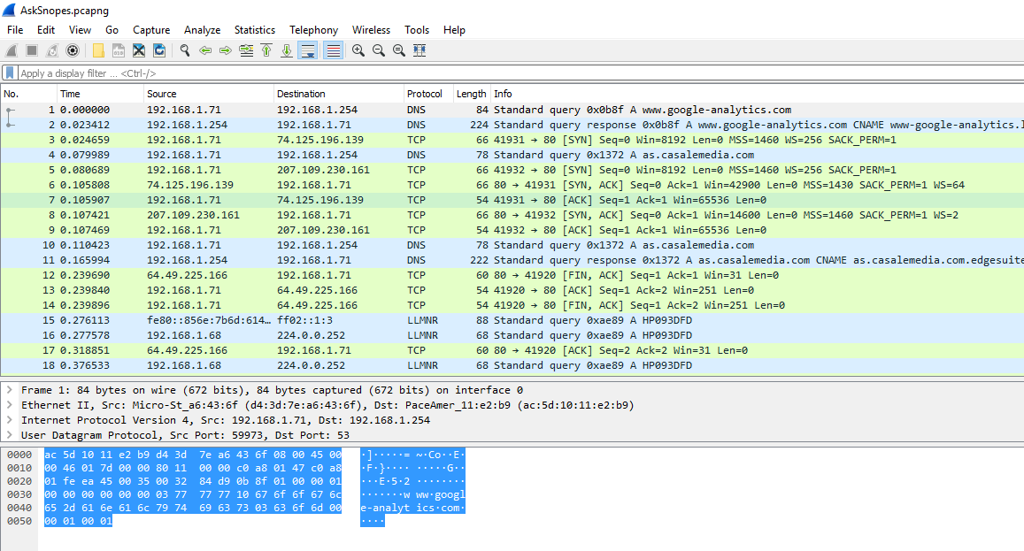

**2. In the display filter type http.**

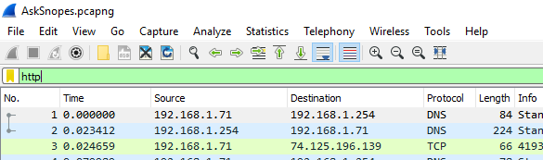

**3. In the second panel expand the hypertext transfer protocol.**

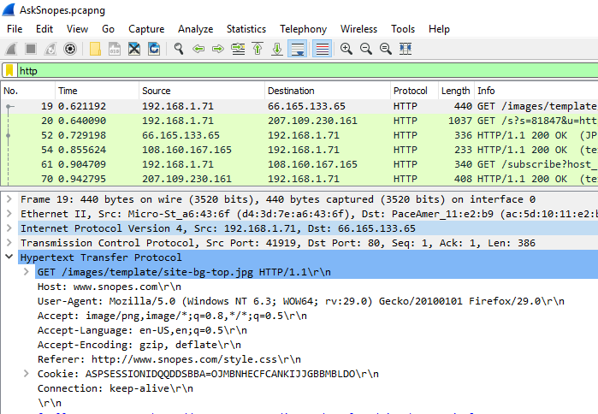

**4. Click on the host name > right click> Apply as column**

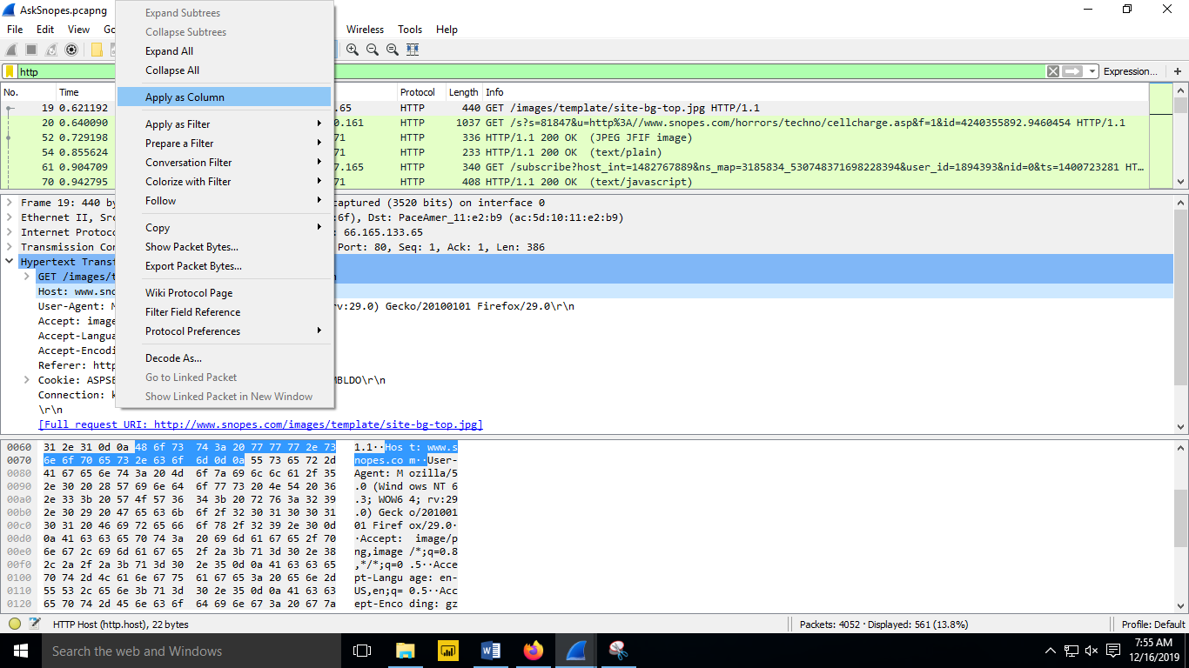

**5. Click any of the http packet > right click> Follow> TCP Stream**

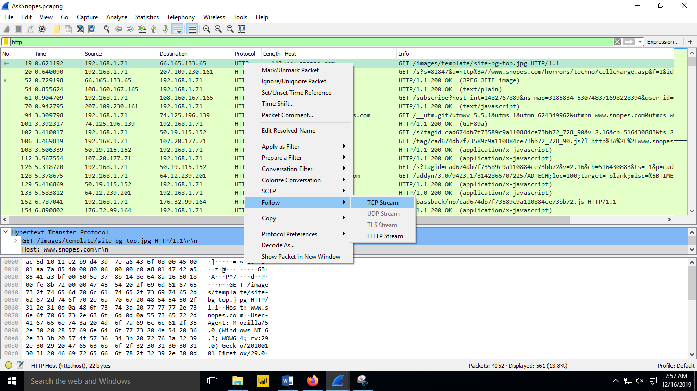

**6. The WebServer is Microsoft IIS/5.0**

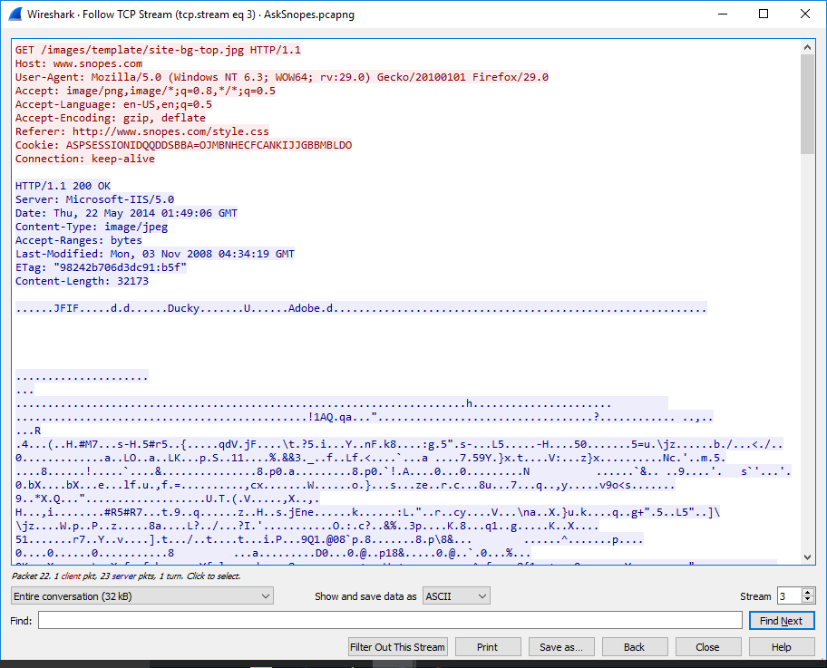

* **About what cell phone problem is the client concerned?**

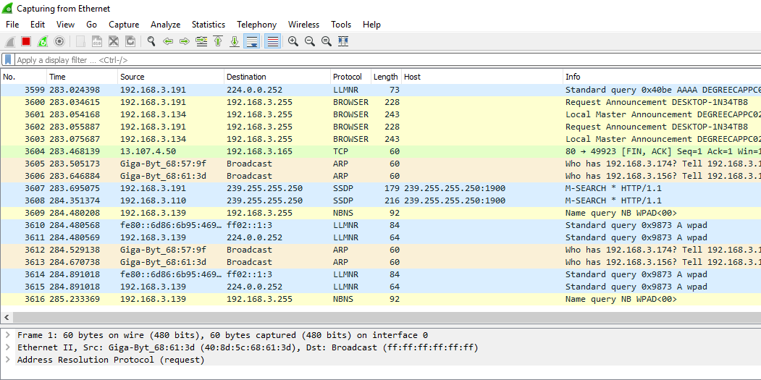

1. **In the display filter type frame matches”(?)cell”**

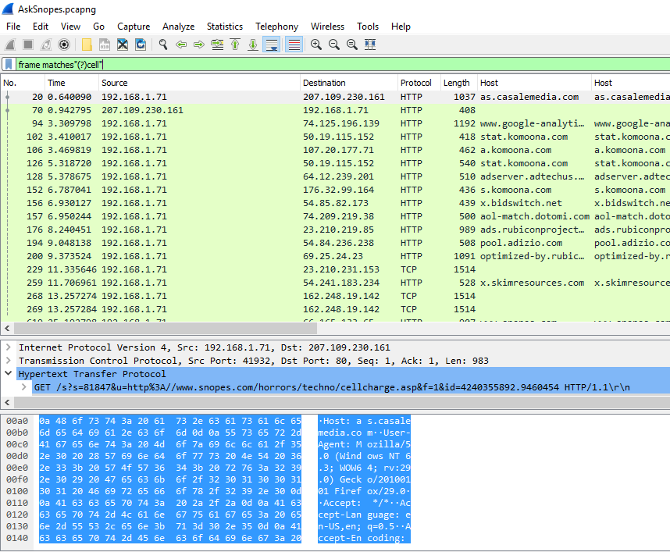

* **According to Zillow, what instrument will Ryan learn to play?**

1. **In the display filter type frame matches”(?)zillow”.**

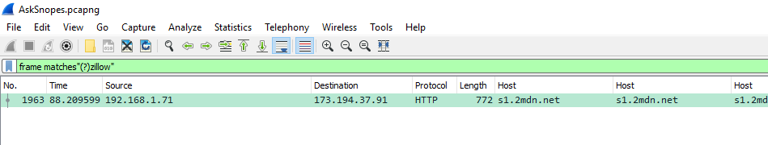

1. **In the second tab expand the transmission control protocol.**

**Right click on transmission control protocol > Protocol Preferences > Allow subdissector to**

**reassemble TCP stream.**

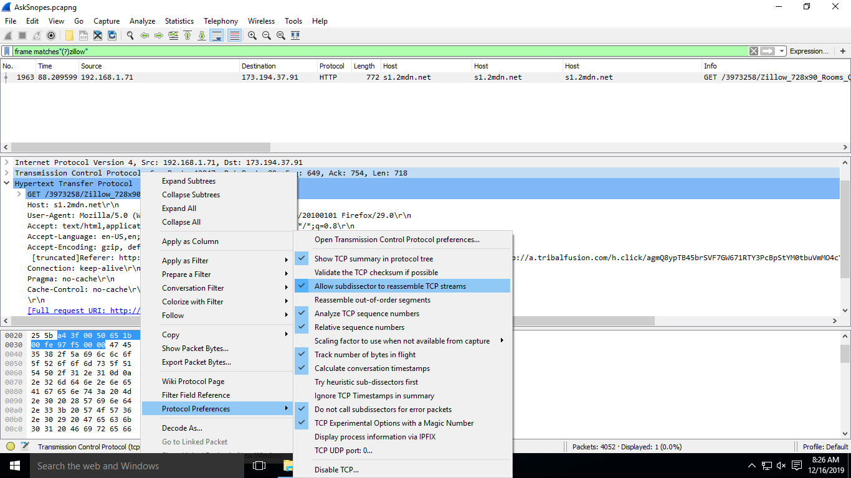

1. **Click on file > Export objects > HTTP.**

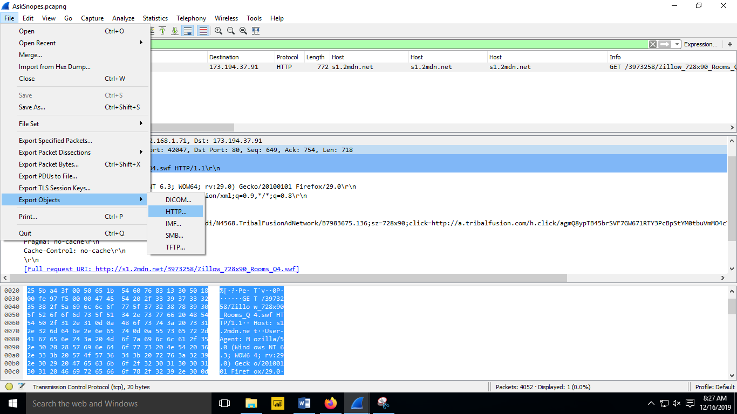

1. **Click on Save all.**

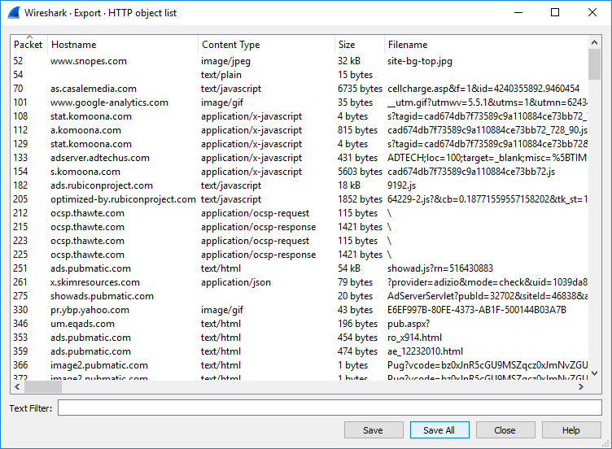

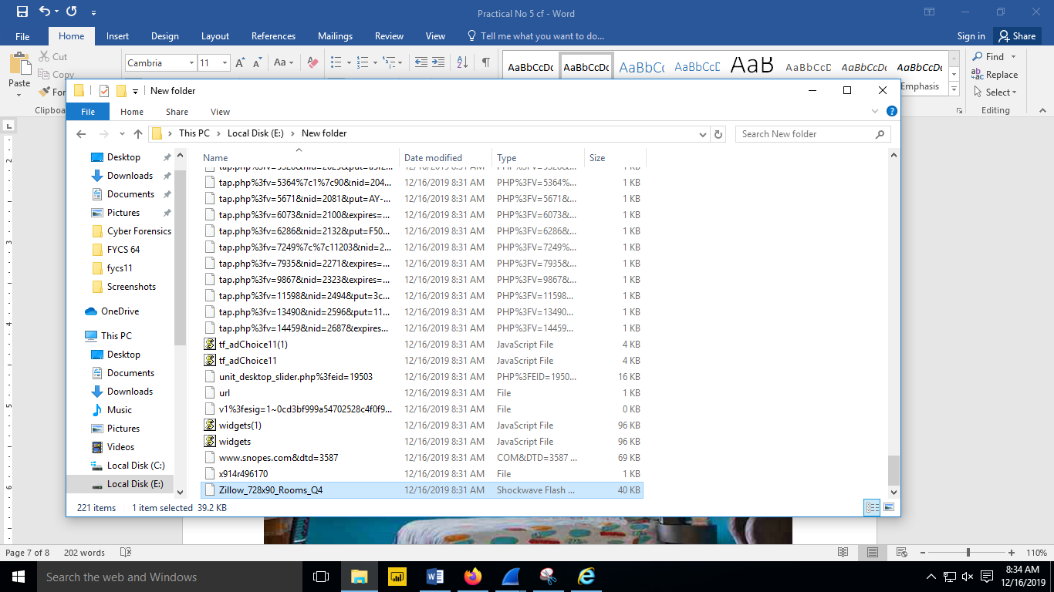

1. **Run the saved file and you will get the result.**

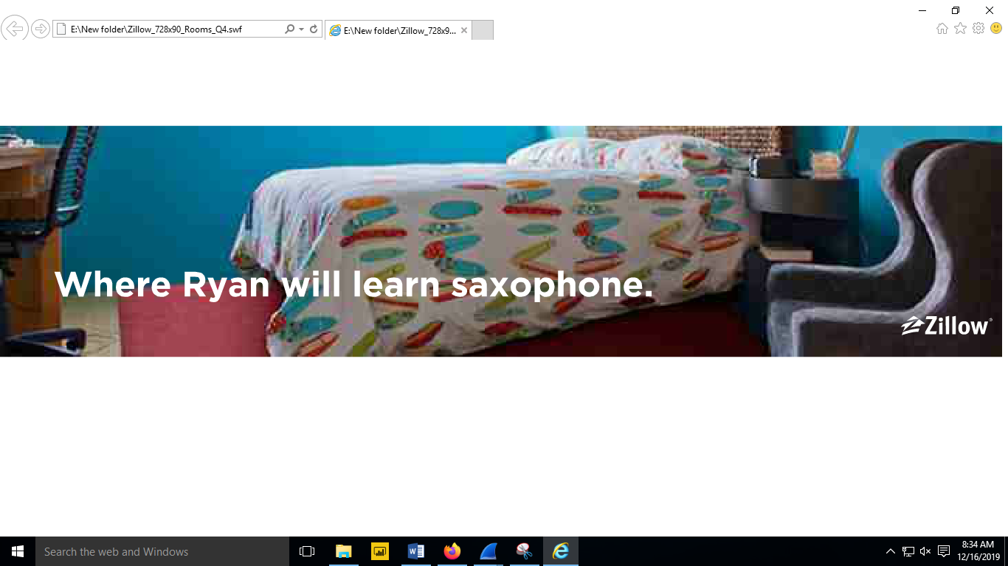

* **How many web servers are running Apache?**

1. **Right click on HTTP > Apply as column.**

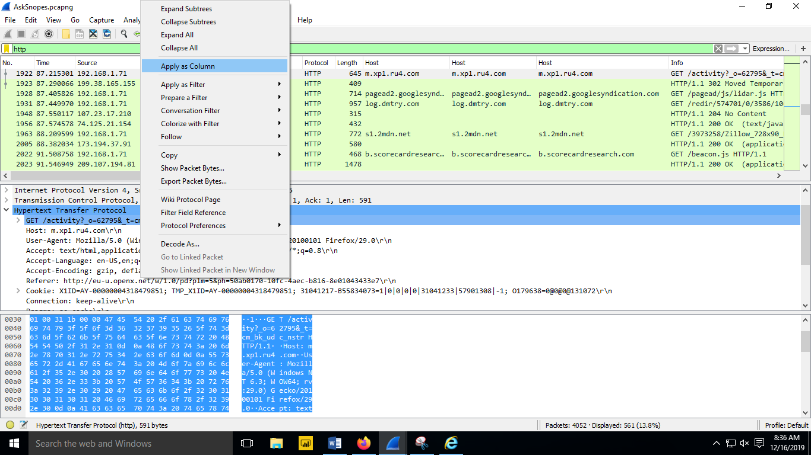

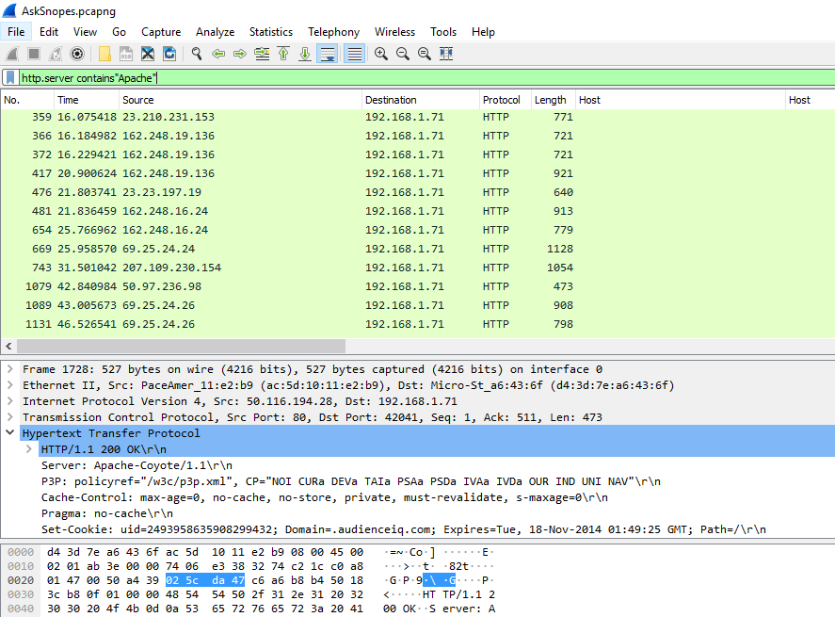

1. **Click on Statistics > Endpoints.**

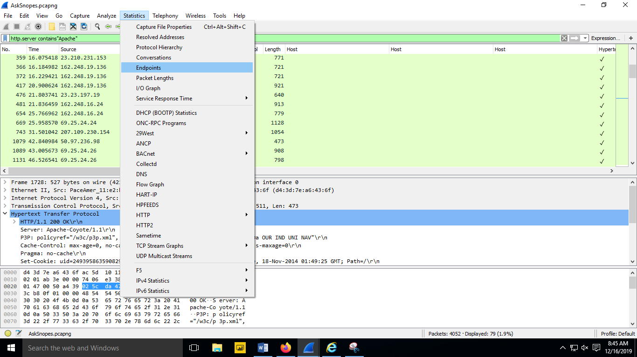

1. **Click the check box.**

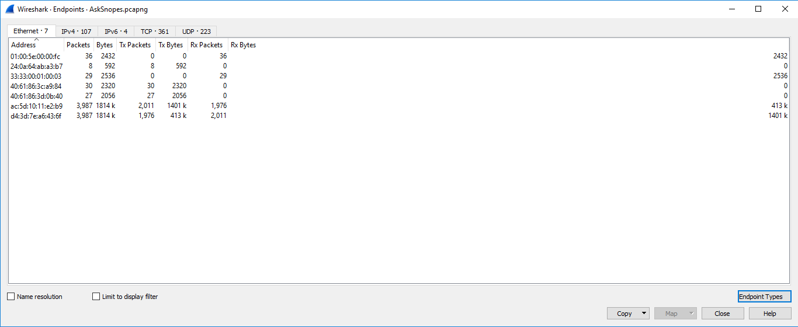

1. **Beside IPv4 the number 21 shows that there are 21 web servers running on apache.**

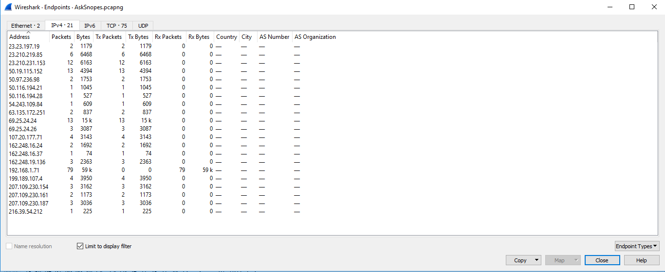

* **What hosts (IP addresses) think that jokes are more entertaining when they are**

**explained?**

1. **In the display filter type frame matches”(?)jokes”.**

